How to Create or Update your Signature in Outlook Web App
Applies to: Microsoft Outlook Web App (mail.queens.edu)
Important: If you use Outlook and Outlook on the web (mail.queens.edu), you need to create a signature in each.

To Configure Your Signature in Outlook Web App:
- Log into Outlook on the web using your account credentials.
- Click on the Settings icon and then expand the Mail option
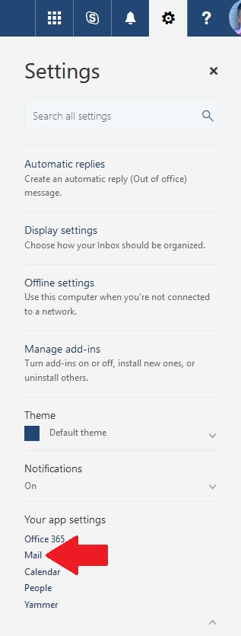
- Under Layout, click Email signature.
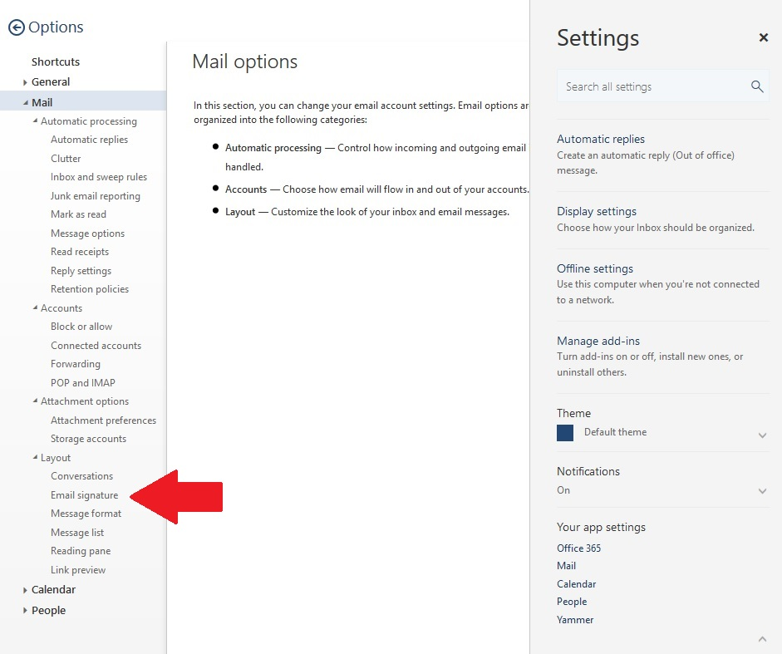
- Highlight and copy the text from the template below
Note: (for now don’t copy the image-we’ll do that separately in the next step)

FIRST NAME LAST NAME
TITLE
Department
xxx.xxx.xxxx | direct
xxx.xxx.xxxx | cell
xxx.xxx.xxxx | fax

- Now, past the text into the signature box in the Outlook Web App
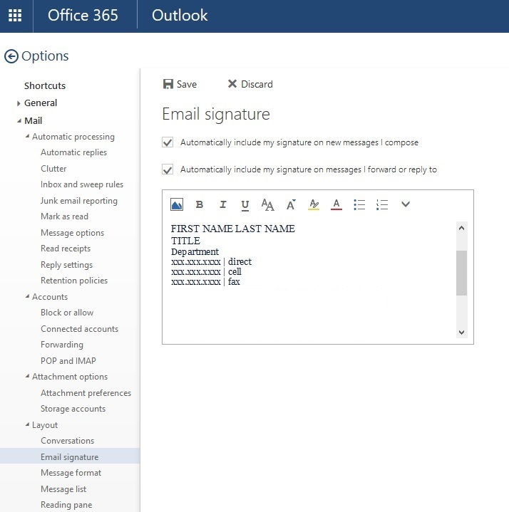

- Next, change the template text to your personal information
- Right-click the blue Queens image located below the template text from step 4 above and select Copy
- Place your cursor in the signature box below your name and contact info
- Press Control-V to past the image into the signature box
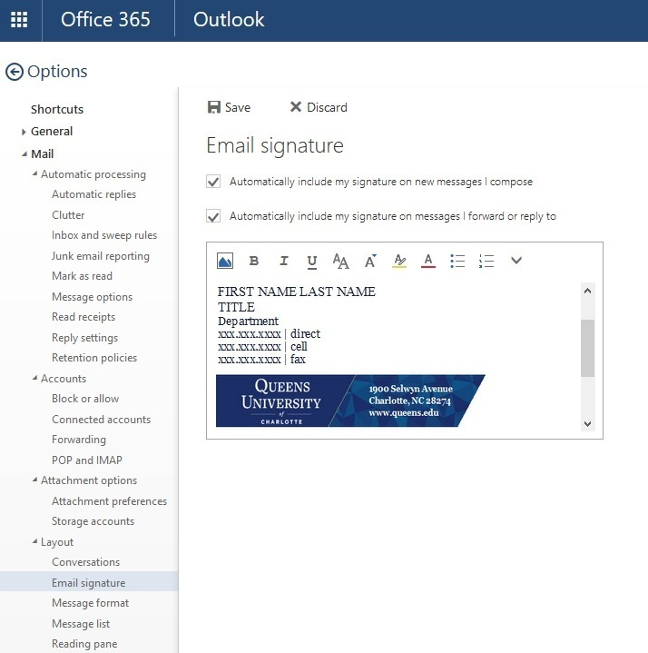

- Click the Save button to save your changes.
- That’s it, you are now finished!

