How to Create or Update your Signature in Outlook
Applies To: Microsoft Outlook 2013, 2016
Important: If you use Outlook and Outlook on the web (mail.queens.edu), you need to create a signature in each.
To setup your Queens Email Signature in Outlook:
  - Create a new email message.
  - On the Message tab, in the Include group, choose Signature > Signatures.
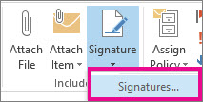
  - If you currently do not yet have a signature, under Select signature to edit, choose New, and in the New Signature dialog box, type a name for the signature.
  - Under Choose default signature, set the following options for your signature:
    - In the E-mail account list, enter your email address
    - In the New messages list, choose the signature that you just added
    - In the Replies/forwards list, again, choose the signature that you just added
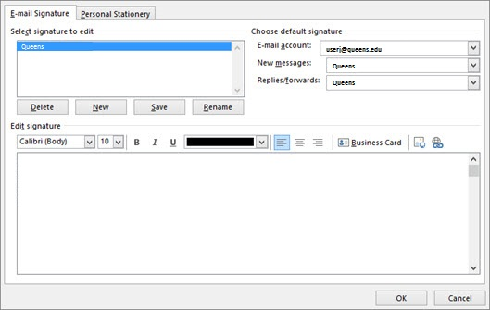
  - Under Edit signature, copy and paste the template below
  - Change the default values for Name, Title, Department, and Phone numbers to your own, and when you are finished choose OK
  - That’s it, you are now finished!

FIRST NAME LAST NAME
TITLE
Department
xxx.xxx.xxxx | direct
xxx.xxx.xxxx | cell
xxx.xxx.xxxx | fax

